INSY6212 MOCK EXAM
ASSESSMENT TYPE: MOCK EXAMINATION (PAPER ONLY)
TOTAL MARK ALLOCATION: 60 MARKS
TOTAL HOURS: 1 HOUR AND 30 MINUTES (+10 minutes reading time)

Question 1 (Marks: 37)
Answer all the questions.

1.1. A project is known to be constrained by several factors or elements. State any three factors that could affect the successful completion of a project. (6)
- Scope
- Quality
- Stakeholders
- Schedule
- Budget
- Resources
- Risk
- Customer Satisfaction
2 marks per factor
1.2. You are presented with the two projects below, Project A and Project B. Study the presented project evaluation and selection then answer the question that follows:

PROJECT EVALUATION AND SELECTION
Criteria | Project A | Project B
Cost | R800 | R150000
Return on Investment | 6.1% | 12.4%
Time to market | 9 months | 12 months
Risk factor | High | Medium
Chances of success | High | High

When choosing between the two projects above, list the four project selection steps to follow. (4)
1. Develop a set of criteria against which the project will be evaluated
2. List assumptions
3. Gather data and information for each project
4. Evaluate each project against the criteria.

1.3. State four attributes of a project. (4)
- Clear objective
- Expected benefits or outcomes.
- Carried out through a set of interdependent activities.
- Various resources
- A specific time frame or finite life span
- Unique or one-time endeavour
- Sponsor or customer.
- Involves a degree of uncertainty.
1.4. Explain what a Request for Proposal (RFP) is and state who prepares it. (3)
A document, prepared by the sponsor or customer, which defines the project requirements and is used to solicit proposals from potential contractors to do the project.
(2 marks for explanation and 1 mark for stating who prepares it)
1.5. Just because the contractor has been selected as the winner does not mean that the
contractor can start doing the work. Before the project can proceed, a contract must be signed between the customer and the contractor. Explain what a contract is and give two types of contracts. (6)
a contract is an agreement between the contractor who agrees to perform the project and to provide a product or service, and the customer who agrees to pay the contractor a certain amount in return. (4 marks)
- Fixed price (1 mark)
- Cost reimbursement (1 mark)
1.6. Differentiate between resource smoothing and resource-limited scheduling. (4)
Resource levelling (smoothing) is a method for developing a schedule that attempts to minimise the ongoing changes in requirements for resources. It levels the resources so that they are applied as uniformly as possible without extending the project schedule beyond its required completion time. (2 marks)
Resource limited scheduling is a method for developing the shortest schedule when the quantity of available resources is fixed. This method is appropriate when the resources available for the project are limited and these resource limits cannot be exceeded. (2 marks)

1.7. Explain the purpose of a project charter and give at least six examples of elements that could be included in a project charter. (10)
Formally authorises a project once selected. The sponsor provides approval to go forward with the project and commits the funding for the project. The project charter summarises the key conditions and parameters for the project and establishes the framework for developing a detailed baseline plan for performing the project. (4 marks)
- Project title
- Purpose
- Description
- Objective
- Success criteria or expected benefits.
- Funding
- Major deliverables
- Acceptance criteria
- Milestone schedule
- Key assumptions
- Constraints
- Major risks
- Approval requirements
- The project manager
- Reporting requirements
- Sponsor designee.
- Approval signature and date

(1 mark per element to a maximum of 6)

Question 2 (Marks: 23 )
Answer all the questions.

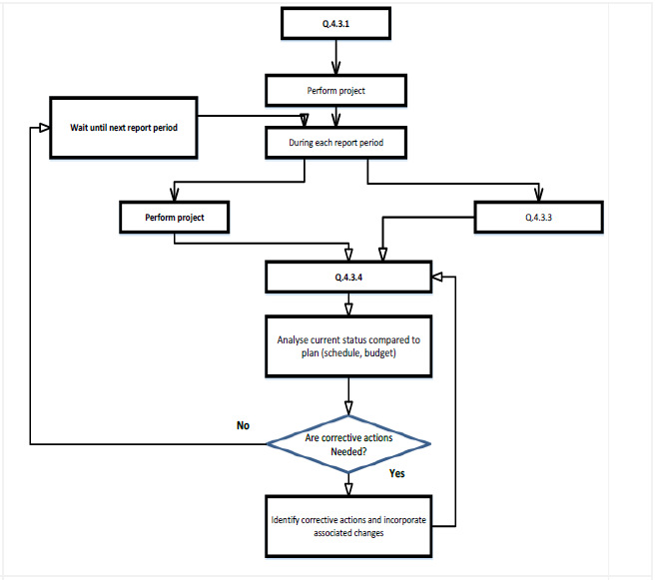
Collect data on actual performance
C
B
A

2.1. Study the diagram above and complete it regarding the project control process by
providing the missing steps in the process. (3)
A – Establish baseline plan (1 mark)
B – Incorporate changes into project plan (1 mark)
C – Calculate updated project schedule, budget, and forecast (1 mark)

2.2. Consider the network diagram below and answer the questions that follow:
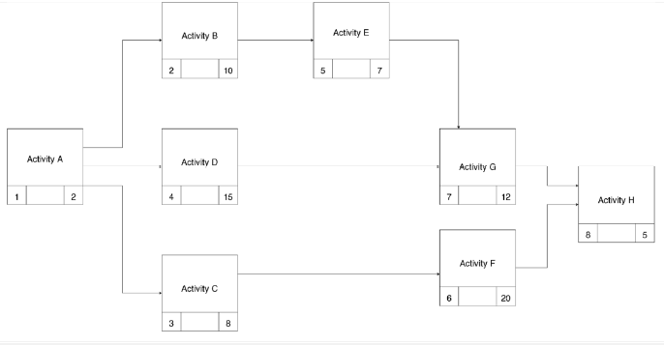
Complete the table below by calculating the Earliest Start, Earliest Finish, Latest Start, and Latest Finish times for each activity, and total slack time for each activity. (20)

- Award one mark for each activity’s ES‐EF + LS‐LF to a maximum of eight marks.
- Award one mark for each total slack time to a maximum of eight marks.
- Award four marks for professionalism and tabular format of the document.
- Award a total of twenty marks.

EF = ES + ED
LS = LF - ED

